**UNIT 4.7   
 E-Commerce Applications**

**TUTOR NAME: MS FATHIMA**

**SUBMITTED BY FATIMA EJAZ BARRI**

Contents

**UNIT 4.7 E-Commerce Applications** 1

# LO1-

# Explain e-commerce principles

Commonly written as ecommerce, electronic commerce is the trade of goods or services using computer networks, such as the internet. Electronic commerce relies on technology such as mobile trading, transfers of electronic money, supply chain management, internet marketing, online transaction processing, electronic data sharing, inventory management systems and automated data collection systems. Current electronic commerce usually uses the World Wide Web for at least one aspect of the life cycle of the transaction, while other technology such as email can also be used.

Ecommerce businesses may employ any or all of the following items:

* Online shopping websites for retail sales direct to consumers,
* Providing or participating in online marketplaces, which process third-party business-to-consumer or consumer-to-consumer sales,
* Business-to-business buying and selling,
* Gathering and using demographic data through web contacts and social media,
* Business-to-business electronic data interchange,
* Marketing to prospective and established customers by email or fax (for example, with newsletters)
* Engaging in pretail for launching new products and services.

Pertail (also referred to as pretail or pre-commerce) is a sub-category of e-commerce and online retail for introducing new products, services and brands to market by pre-launching online sometimes as reservations in limited quantity before release, realization, or commercial availability. Pretail includes pre-sale commerce, pre-order retailer, incubation marketplaces, and crowdfunding communities. (Wikipedia 2015)

# LO1-

Q1. Ruskana does not understand anything about the principles and concepts of ecommerce and therefore she has asked you to produce a report which explains:

* 1. e-commerce principles
  2. the relationship between ecommerce principles and ecommerce models
  3. the effect of ecommerce applications on different types of organizations

Task 1a:

Electronic commerce or ecommerce refers to a wide range of online business activities for products and services. It also pertain to “any form of business transaction in which the parties interact electronically rather than by physical exchanges or direct physical contact”

Ecommerce is usually associated with buying and selling over the internet or conducting any transaction involving the transfer of ownership or rights to use goods or services through a computer-medicate network. Though popular, this definition is not comprehensive enough to capture recent developments in this now and revolutionary business. Phenomenon. A more complete definition is Ecommerce is the use of electronic communications and digital information processing technology in business

# Explain the relationship between e-commerce principles and ecommerce models

**Relationship between ecommerce principles and models:**

B2B:

B2B ecommerce is simple defined as ecommerce between companies. This is the type of ecommerce that deals with relationships between and among businesses about 80% of ecommerce is of this type and most experts predict that B2B ecommerce will continue to grow fast. The B2B market has two primary components: e-Frastructure and e-markets. E-frastrucutrue is the architect of B2B, primarily consisting of the following:

* Logistics: transportation, warehousing and distribution.
* Application service providers: deployment, hosting and management of package software from a central facility.
* Outsourcing of functions in the process of ecommerce such as web hosting security and customer care solutions.
* Auction solutions software for the operation and maintenance of real time auctions in the internet
* Content management software for the facilitation of web site content management and delivery
* Web based commerce enablers.

The more common B2B examples and best practice models are IBM, Hewlett Packard (HR), cisco and dell. Cisco for instance, receives over 90% of its products orders over the internet. Transmission of shipping documents), channel management (i.e. information dissemination on changes in operational conditions and payment management (e.g. electronic payments systems or EPS).

**B2C:**

Business to consumer ecommerce, or commerce between and consumers, involves customers gathering information, purchasing physical goods (i.e.: tangibles such as books or consumer products or information goods or goods of electronic materials or digitized content, such as software or e-books and for information goods, receiving products over an electronic network.

* **Business to business model (B2B)**

**Business to consumer (B2C)**

It is the exchange of products, services or information between business and consumers in a retailing basis, the consumers browse product on the desired website and pay for the goods at checkout by any mode of payment. The owner of the ecommerce site needs to check and maintain the website regularly for gaining better customers.

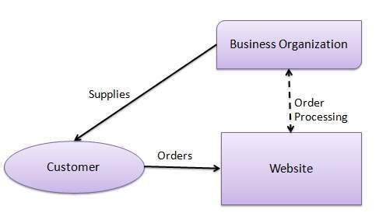

Emergeapp.com, 2010

* **Business to consumer model (B2C)**
* **Consumer to consumer (C2C)**

It is a type of business model that involves consumers interacting directly with other consumers. An individual can buy and sell products or services directly to other individuals.

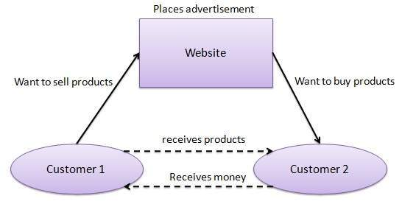

tutorialspoint.com, 2020

**Consumer to business model (C2B)**

Consumer-to-Business (C2B)
Like
Daraz.pk
 

Slideshare.net.com, 2018

This type of ecommerce comes in at least forms:

* Auctions facilitated at a portal, such as eBay which allows online real time bidding on items being sold in the web.
* Peer-to-peer systems, such as the napster model (a proctor for sharing files between users used by chat forums similar to IRC) and other file exchange and later money exchange models.
* Classified ads at portal sites such as excite classifieds and e-wanted, pakwheels.com (an interactive, online marketplace where buyers and sellers can negotiate and which features “BUYERS LEADS & WANTS ADS”)

There is little information on the relative size of global C2C ecommerce. However C2C figures of popular C2C sites such as eBay and napster indicate that this market is quite large. These sites produce millions of dollars in sales every day.

# Task 1c:

**The effect of applications in organizations are as such that it will impact the organizations in many different ways:**

* The effect of e-distributor, which is a supplier oriented marketplace is suppling products and services directly to individual businesses.
* The effect of e-procurement, which is a buyer oriented marketplace, is creating firms that create and sell access to digital electronics markets.

There are different applications of ecommerce and they are:

* E-distributor (supplier oriented marketplace)

E-distributor is a type of ecommerce distribution that uses purely electronic media as a mean of distribution. It is often seen as the buying and selling of goods and services over a public network with the use of electronic media without the physical media. This procedure is usually done by downloading content from the internet to the consumer’s electronic devices. This type of distribution is widely accessible to large numbers of customers and for business since there is no need to provide a physical media. The process the follows up with the company that will supply products and services directly to individual businesses.

* e-distributor diagram

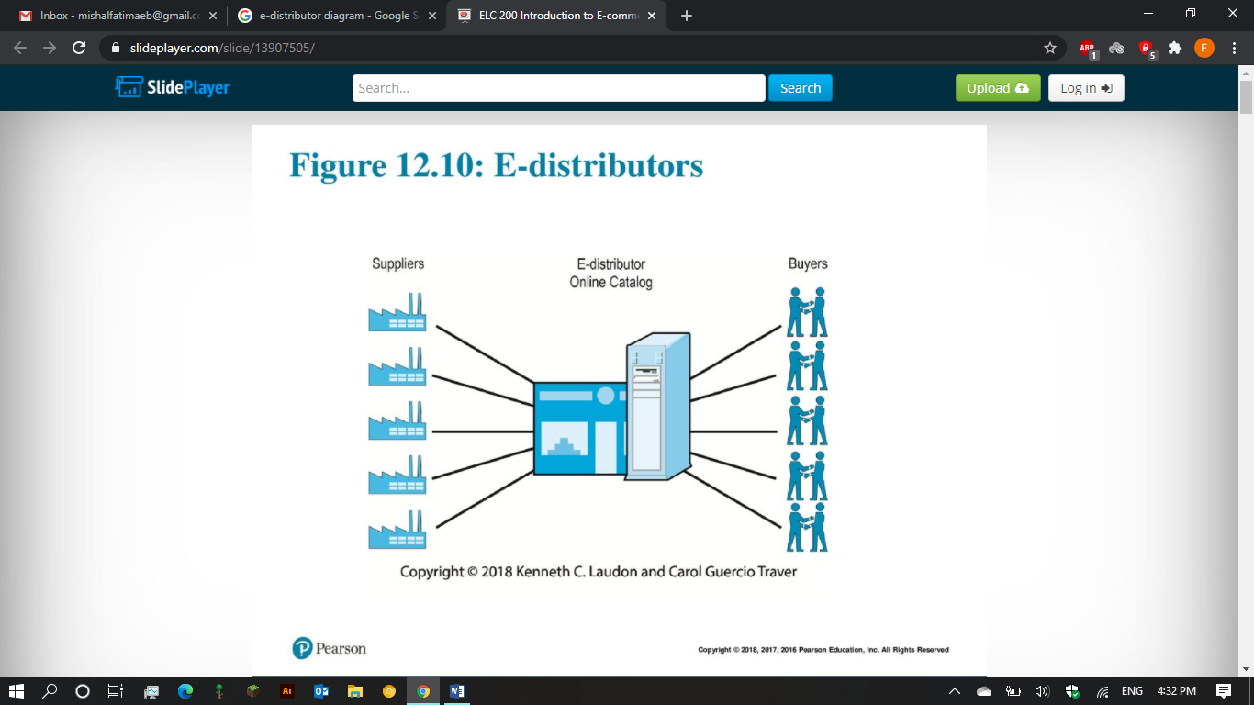

Slideplayer.com, 2018

* E-procurement (buyer oriented marketplace)

Just as e-distributors provide products to other companies, e-procurement firms create and sell access to digital electronic markets. E-procurement s the business to business or business to consumer purchase and sale of supplies, work and services through

* **EProcurement process diagram**

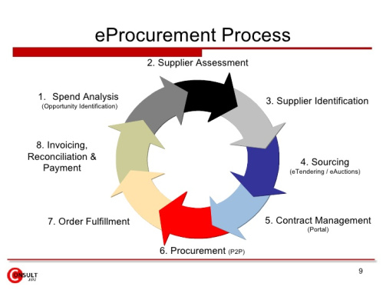

claireisslim.wordpress.com, 2015

**Supply chain:**

A supply chain is a system of organizations, people, activities, information and resources involved in moving a product or service from supplier to customer. Supply chain activities involve the procurement and transformation of natural resources, raw materials and components into a finished products that is delivered to the and customer. Supply chains include every business that coms in contact with a particular product, including companies that assemble and deliver component parts to the manufacturer.

Effective supply chain management (SCM) has become a potentially valuable way of securing competitive advantage and improving organizational performance since competition is no longer between organization but among supply chains also competitive advantage can have a direct positive impact on organizational performance

**Supply chain management diagram**

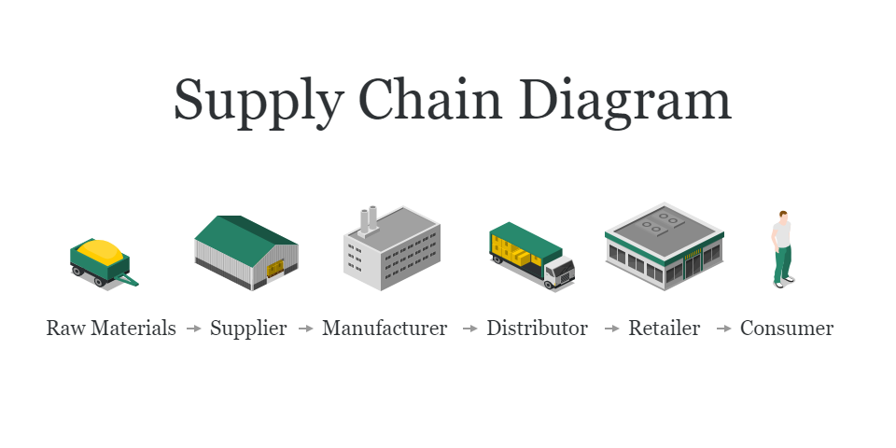

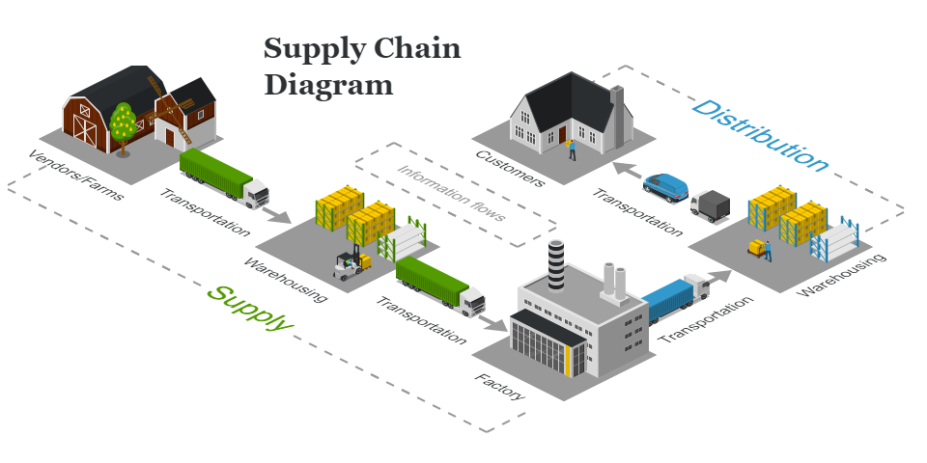

icograms.com, 2016

* Customer relationship management (CRM):

Customer relationship management (CRM) is a term that refers to practices, strategies and technologies that companies use to manage and analyze customer interactions and data throughout the customer lifecycle, with the goal of improving business relationships with customers, assisting in customer retention and driving sales growth. CRM systems are designed to compile information on customers across different channels or points of contact between the customer and the company which could include the company’s

**E-commerce security:**

There are six key features of ecommerce security and they are:

* Integrity:

They ability to ensure that information being displayed on a website or transmitted or received over the internet over the internet has not been altered in any way by an unauthorized party.

* Non repudiation:

Non repudiation refers to the ability to ensure that ecommerce participants do not deny i.e. repudiation their online actions

* Authenticity:

Authenticity refers to the ability to identify the identity of a person or entity with whom you are dealing on the internet

* Confidentiality:

Confidentiality refers to the ability to ensure that message and data are available only to those who are authorized to view them

Task 2a:

Ecommerce can be very useful for a small business such as organic toy company and there are many benefits such as tangible and intangible benefits. Tangible benefits are the benefits that can be measured or quantified such as increase in sales, decrease in administration costs, increased revenue etc. intangible benefits are the benefits that cannot be measured or quantified such as customer satisfaction, brand success etc.

The benefits of ecommerce to a business such as organic toy company include

* Convenience and easiness
* Online presence establishment
* Attracting new customers
* Saving on operational costs
* Better understanding of customers
* Boost brand awareness
* Decreasing cost of inventory management
* Worldwide availability of products
* Open 24/7 * 365 days
* Increase in customers
* Instant transaction processing

Convenience and easiness:

Ecommerce has all the convenience and ease of use for the customers as they can shop at any time of the day. The best part about ecommerce is that the buying options are quick, convenient and user-friendly with the ability to transfer funds online. Because of its convenience, consumers can save their lots of time as well as money by searching their products easily and making purchasing online.

Online presence establishment:

More than 80% of the online population has used the internet to purchase something. Customers expect the shop to be available, and this presence allows the shop to keep up with the competition. Audience will be flocking towards the competitors to make an online purchase.

Attracting new customers:

As an ecommerce business owner, the owner wants to grow the business and attract new audiences. Physical retail relies on branding and customer relationships, but online retail has the added benefit of driving traffic from the search engines. For e.g.: if a customer is doing a search for photo editing software for instance they may land on the company even though they’ve never heard of the company before.

Saving on operational costs:

Running an ecommerce website can actually save money. With a web based management system, owner can automate inventory management and decrease the costs associated with it. Also, running an ecommerce store doesn’t come with the same overhead costs as a physical store. The additional profile that is made from reaching more customers will offset any initial setup costs.

Better understanding of customers:

Based on the purchases that the customers make on a regular basis, the ecommerce website owner can get a clear picture of who is interested in certain brands and products so that means that the customers will be understood better by this medium.

Boost brand awareness:

Ecommerce will help the brand to get more awareness in the online landscape. As the owner develops more web pages, the search engines can index them and boost the placement. It’s important to use good keywords in the content that are optimized for the audience, as this is what will drive traffic to the ecommerce site. As the site gets more visibility, people will become familiar with the brand and reputation.

Decreasing cost of inventory management:

With ecommerce business, the suppliers can decrease the cost of managing their inventory of goods that they can automate the inventory management using web based management system. Indirectly, they can save their operational costs.

Worldwide availability of products:

Here are the steps of how ecommerce works:

1. A customer tries to order a book online. Her web browser communicates back and forth over the internet with a web server that manages the stores website.
2. The web server sends her order to the order manager. This is a central computer that sees orders through every stage of processing from submission to dispatch.
3. The order manager queries a database to find out whether what the customer wants is actually in stock.
4. If the item is not in stock, the stock database system can order new supplies from the wholesalers or manufacturers. The might involve communicating with order systems at the manufacturers HQ to find out esteemed supply times while the customer is still sitting at her computer (in other words, in real time)
5. The stock database confirms whether the item is in stock or suggests an estimated delivery date when suppliers will be received from the manufacturer.
6. Assuming the item is in stock, the order manager continues to process it. next it communicates with a merchant system (run by a credit card processing firm or linked to a bank) to take payment using the customer’s credit or debit card number.

Task 2c:

Although there are various threats that are associated with the use of ecommerce, there are many solutions that can be found to combat the threats and to make ecommerce a safe mean of communication.

Solutions:

As threats are associated with the use of ecommerce, there are many solutions that can combat these threats and make ecommerce a safe mean of business communications. Beacause e-commerce transactions must flow over the public internet and therefore

|  |  |  |
| --- | --- | --- |
| Revenue model | Examples | Revenue source |
| Advertising | Yahoo | Fees from advertising in exchange for advertisements |
| Subscription | WSJ.COM  Consumerreports.org | Fees from subscribers in exchange for access to content or service |
| Transaction fee | eBay  e-trade | Fees (commissions) for enabling or executing a transaction |
| Sales | Amazon  ITunes | Sales of goods, information or services |
| Affiliate | My points | Fees for business referrals |

According to the scenario, Ruksana should go for the sales and advertising as these revenue models will help Ruksana Company to fulfil the needs of the business by making advertisements that will capture the interests of the customers in order for them to buy the products. The sales revenue model is also very important as the way the goods are sold and the information given about the goods play a very important role in selling the goods.

Task 3c:

Ecommerce strategies:

A business is a set of plans for achieving superior long-term returns on the capital in a business firm. A business strategy is therefore a plan for making profits in a competitive environment over the long term.

Differentiation:

Differentiation refers to all the ways producers can make their or services unique and distinguish them from those of competitors.

Unique ways to differentiate products and services:

Ecommerce offers some unique ways to differentiate products and services, such as the:

* Ability to personalize the shopping experience and to customize the products or service to the particular demands of each consumer.

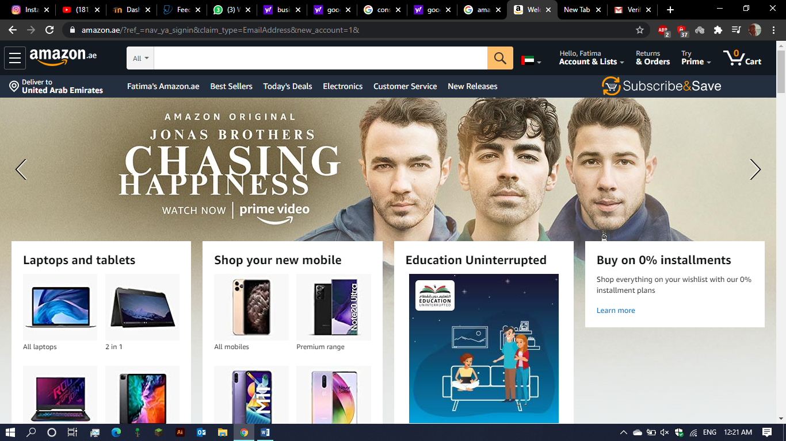

The internet is crucial to the smooth operation of ecommerce. Business using ecommerce alone need a fast, reliable service without an internet connection and the huge development in multimedia there would be very limited ecommerce opportunities of course the fast pace of technological change does increase the demand for ecommerce just as the demand in turn increase the need for faster cheaper technology.

Unique feathers of ecommerce technology:

The eight feathers of ecommerce technology are:

1. Ubiquity
2. Global reach
3. Universal standards
4. Richness
5. Interactivity
6. Information density
7. Personalization / customization
8. Social technology

Ubiquity:

Ubiquity is defined as being something that occurs everywhere. Internet and web technology is readily available everywhere so that users can make use of them wherever they are. So a marketplace is created and online shopping, or ecommerce can occur anywhere.

Global reach:

Global reach is basically when technology and spans across the entire world, which makes the potential market space and base attracting billions of customers. The market space is online and encompasses every single type of business we can imagine from amazon which sells a little bit of everything to much more focused business such as lights and lighting manufactures. Global reach allows previously unheard of retailers to sell to the other side of the world, while it also connects the bigger sellers with new opportunities as well.

Universal standards:

Another important feather is universal standards. It means that there is one set of technology standards, which are called internet standards. The internet has its own universally accepted standards of how information is presented. This equalizes the playing field for many business because it means anyone can access the information they need to enter the market and also prince discovery is no longer a problem.

Richness:

Richness is when there is a variety of media to capture the customer’s interest in the product such as interactive menus and displays that contain video ads, audio messages and even interactive text options on various online stores. Businesses amplify their adverting power by using new methods to catch potential buyer’s attention. This makes the customers much more likely to purchase something, since they know exactly what they’re looking for

Interactivity:

Interactivity is basically how users interact or behave with the target area interactivity is the most standardized element in most of the business especially ecommerce   
interactivity can be achieved by the website by providing online agents to aid us in certain issues and giving lots of options for customers to choose.

Information density:

It basically means the reduction of information costs and raising quality of information. The density of information has greatly improved on the internet and as a result, all the markets consumers and business information are of top quality they ecommerce technology reduces the costs of information gathering, storages communication and processing. At the same time, accuracy and timeliness of the information technology increases greatly so information is more useful and important than ever.

Personalization / customization:

Ecommerce technology allows for personalization businesses can be adjusted for a name, a person’s interests and past purchase message objects and marketing message to a specific individual. The technology also allows for custom options and choices. Merchants can change the product or service.

Social technology:

(Draft)

And registers another bank account he/she then places a request to transfer certain amount to that account. Customer’s bank transfers amount to other account if it is in same bank otherwise transfer request is forwarded to ACH (automated clearing house) to transfer amount is transferred to other account, customer is notified of the fund transfer by the bank.

Task b:

E-commerce is usually associated with buying and selling over the internet through a computer-mediated network. A more elaborate definition is “E-commerce is the use of electronic communications and digital information processing technology in business transactions to create, transform and redefine relationships for value creation between or among organization, between organization and individuals”.

1. Business to business (B2B)

This involve the exchange of products, services or information between different business entities. B2B connects the manufacturers, suppliers’ buyers, sellers, traders, dealers, distributors, importers, exporters and other businesses people directly in a single line without any interruptions. In B2B ecommerce, both the business use electronic means of buying, selling. Purchasing and exchanging of goods and services between themselves.

# LO4

Ruskana is pleased with your presentation and has decide to go ahead with an online presence. She has asked you to create an e-commerce site in line with industry standards.  
You will present your solution to Ruksana demonstrating the appropriate use of an e-commerce application.

Link: <https://fatimaejazb.wixsite.com/organictoycompany>

**HOME SCREEN**

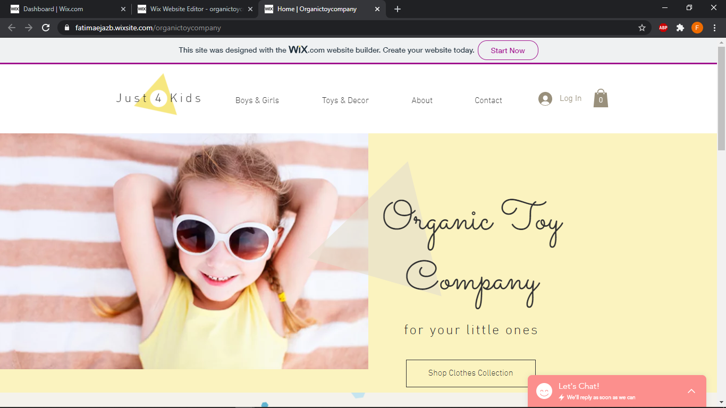

**CART PAGE**

**PRODUCT DESCRIPTION**

# LO5

Ruksana has provided you with feedback on your e-commerce site and she has asked other possible users to do the same. You are keen to learn from this feedback. Produce a personal file document which draws together the review of the feedback and in particular your use of an ecommerce application and how this will be maintained and supported.

* <https://slideplayer.com/slide/13907505/>
* <https://icograms.com/usage-supply-chain-diagram.php>
* <https://icograms.com/templates/logistics-supply-chain.png>
* <https://icograms.com/templates/logistics-supply-chain-diagram.png>
* <https://emergeapp.net/wholesale-business/b2b-ecommerce/>
* <https://www.tutorialspoint.com/e_commerce/e_commerce_business_models.htm>
* <https://claireisslim.wordpress.com/2015/06/04/e-procurement-on-line-inventory-procurement/>
* <https://www.slideshare.net/MemonaJamil/e-commerce-business-models-108347415>